Technical Report on my Routing & Wireless Network design for Irish Retail Chain, Emerald Retail Ltd. Headquarters

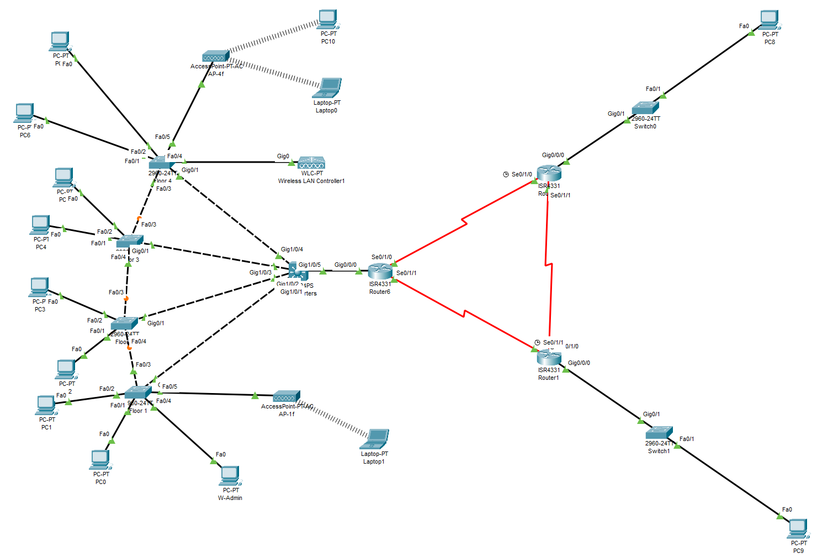

By: Shehab Ahmed (C00295178)
Cybercrime and IT Security Year 2 (SE606)
Submission Date: 09:00, 7th April 2025

Table of Contents

1. Introduction 3
2. Body 4
2.1. Departmental Segmentation using VLANs 4
2.1.1. Number of VLANs and their purpose 4
2.1.2. Inter-VLAN Communication 6
2.1.3. VLANs Physically or Logically grouped? 7
2.1.4. Devices per VLAN 8
2.2. Dynamically allocated IPv4 and IPv6 addresses with subnetted networks 9
2.2.1. DHCP Server or MLS IOS Integrated? 9
2.2.2. IPv4 and IPv6 Addressing with Dynamic Allocation 10
2.2.3. Excluded IP Addresses 11
2.3 Layer 2 Security Measures 11
2.3.1 MAC Table Attacks 12
2.3.2 VLAN Attacks 13
2.3.3 STP Attacks 14
2.3.4 DCHP Attacks 14
2.3.5 ARP Spoofing 15
2.4 SSH to Headquarters’ Edge Router 15
2.5 Static Routes for External Communication 16
2.6 Branch offices IP Address allocation 18
2.7 Basic Wireless Network 19
3. Conclusion 21

- Introduction

The purpose of this report is to explain in detail the design I chose and the reason for the decisions I’ve made in the design. This report will also be going over some flaws in the topology and what I would do in a different setting with different equipment.

There are five major requirements fulfilled in the design and depicted in this report:
- Departmental Segmentation using VLANs
  - How many VLANs?
    - Purpose of each
  - Iner-VLAN communcation
  - Physically or logically grouped. Or both?
  - Devices per VLAN

- Dynamically allocated IPv4 and IPv6 addresses and with subnetted networks
  - Connection established and Stable communication?
  - Inter-VLAN communication?

- Layer 2 security measures to mitigate:
  - MAC Table Attacks
  - VLAN Attacks
  - STP Attacks
  - DHCP Attacks
  - ARP Spoofing

- SSH establishment with local authentication

- Static routes configuration for external connectivity
  - How? Why not other ways?
  - Why floating routes?

- Branch office segmentation and dynamic IP address allocation
  - Where is dhcp server? How working?
  - Why not standalone dhcp server?

- Basic Wireless network configuration
  - How worked? WLC and AP config – Why not another way?
  - Security measures
  - Dhcp

For each requirement, you’ll be provided with the reason as to why I chose to fulfil the requirements the way I did. These fulfilments will be elaborated on and compared side by side with other competing fulfilments to obtain a deeper understanding of my project. Finally, a conclusion will be provided to summarise why the design I chose best fits the network requirements for Emerald Retail HQ and its two branch offices in Cork and Galway.
The Inter-VLAN communication method I chose was the Layer 3 Switch because it has less latency than Router-on-a-Stick and the Legacy approach. Using the Layer 3 switch means that the LAN is scalable beyond 50 VLANs. This will be talked about in more depth below.

- Body

  - Departmental Segmentation using VLANs
    - Number of VLANs and their purpose

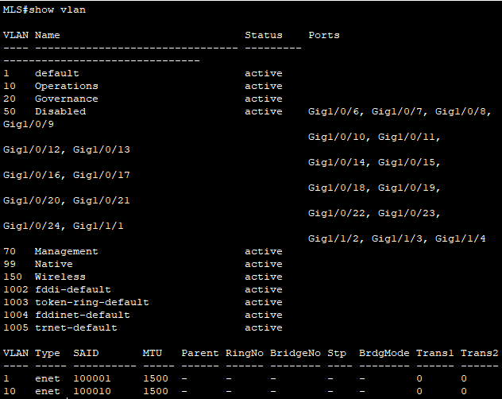
Figure 1 - VLANs set up on the main MLS and on all switches in HQ

The minimum requirements for the amount VLANs to use in the design were:
- Operations (VLAN 10)
- Governance (VLAN 20)
However, I felt that was too little for a few reasons.
To begin, the two mandatory VLANs to have in the topology are missing a specific group of individuals. The group that will manage this design in Emerald Retail HQ. I decided it was best to add a VLAN for Network Infrastructure Management, under VLAN 70 named “Management”. This group will need to manage and control network devices without interference from other traffic. This VLAN will ensure this group of network managers are separated from general office executive managers and maintainers. Keeping traffic from both VLANs separated is crucial to:
- Improve the security of the network – More segmented infrastructure
- Mitigate possible confusions of respected departments in the future
This will also heavily stabilise the network by allowing the management team to access and maintain intermediary devices, even when other user VLANs are experiencing issues (such as high traffic or errors).
Secondly, if there were any guests that needed internet connection for an emergency, they wouldn’t have a suitable VLAN to be placed under, hence bringing risk into the hospital environment. The solution I chose for this was to add a Native VLAN (VLAN 99). This native VLAN would carry user generated and untagged traffic for general data transfer in case a guest is using a legacy device. This ensures they connect successfully to the network.
Also, this allows us to move ports away from the default VLAN of 1. The users in the Native VLAN are the guests that need internet connection from HQ. Again, user generated traffic needs to be separated from departments in the office for link load balancing and overall network security.
Additionally, I wanted the network to be up to date with modern technology. A way in which I chose to update it is to implement a Wireless VLAN (VLAN 150) for mobile devices in the network. This ensures wireless devices don’t interfere with the rest of the network upon connecting. These devices also shouldn’t be able to communicate with the branch offices in Cork or Galway, which is already implemented and fully functional.
Lastly, the addition of a Disabled VLAN (VLAN 50) in the network design serves as a security measure to prevent unauthorized access through inactive or unused ports. By placing all unused or unassigned ports into a dedicated VLAN, any device plugged into these ports will be automatically isolated from the rest of the network, preventing it from gaining access to sensitive resources stored on devices in office or inadvertently interfering with network traffic. This configuration helps to:
- Mitigate the risk of unauthorized devices connecting to the network like:
  - Malicious Actors
  - Rogue Devices
- Ensure all devices are intentionally connected and properly secured
The unused VLAN acts as a safeguard to the network, ensuring that only properly configured and authorized devices are active and functional on the network.
In conclusion, the:
- Management VLAN ensures that network management traffic is securely isolated from regular user traffic.
- Native VLAN allows for the seamless handling of untagged traffic, ensuring compatibility with legacy devices and simplifying trunk link operations.
- Wireless VLAN is added to ensure new users joining the network through wireless join the wireless VLAN and not interfere with the wired network.
- Disabled VLAN adds an extra layer of security by preventing unauthorized devices from accessing the network through unused ports.

    - Inter-VLAN Communication

Inter-VLAN communication is vital for the data in HQ to reach its destination. In this scenario, a device in VLAN 10 might need to send traffic to a device on VLAN 20. If each VLAN is isolated without inter-VLAN communication, users in one VLAN wouldn't be able to access shared resources located in other VLANs. Without inter-VLAN routing, the network would be fragmented, reducing efficiency and causing operational bottlenecks.
Three main points that need to be covered here are:
- Access to Shared Resources on a different VLAN
- External Internet Connectivity (In more detail later)
- Efficient Troubleshooting and Security Management
Users on different VLANs may all need to access external resources from a device in the Galway office. Without inter-VLAN communication, these different VLANs would be isolated, preventing them from accessing this essential service and possibly more in the future. A Layer 3 switch, which routes traffic between VLANs, ensures that all devices can communicate with shared services and external networks without restriction.
Finally, When VLANs can communicate with one another, it’s easier to diagnose and troubleshoot issues across the entire network. For example, if there’s a performance issue with a server shared between different VLANs, the network administrator can trace the traffic across different VLANs and pinpoint where the issue lies. Without inter-VLAN routing, isolated networks would complicate diagnostics and network performance monitoring. Tools that monitor and analyse network traffic and performance rely on inter-VLAN communication to give an overall view of the network's health.

    - VLANs Physically or Logically grouped?

In the Emerald HQ's network design, VLANs are logically grouped rather than physically grouped to provide greater flexibility, scalability, and efficient management of network resources. Logical grouping allows the office to optimize its network traffic, improve security, and better allocate resources across different departments, regardless of their physical location in the building. Below are the key reasons why I chose to logically group the VLANs instead of physically grouping them:
- Network Scalability and Flexibility:
Logical VLAN grouping allows departments to be segmented based on function, rather than physical location. This flexibility enables departments to expand, relocate, or change without needing to rewire the network. For example, if a department grows or moves to another floor, its VLAN membership remains the same, simplifying network management and reducing disruption.
- Simplified Network Management:
Logical VLANs make network management more efficient by allowing administrators to configure policies, permissions, and routing based on logical groupings of users, rather than having to manage network configurations based on physical layout. This leads to reduced complexity in managing access control, applying security policies, and troubleshooting network issues.
- Cost-Effectiveness:
By logically grouping devices into VLANs, the headquarters can make more efficient use of existing network infrastructure without needing to invest in additional physical hardware, such as separate switches for each department. This reduces the overall cost of the network while still achieving the necessary segmentation and security.
- Simplified Troubleshooting:
Logical VLANs simplify network troubleshooting by enabling network administrators to isolate issues to specific VLANs, rather than being limited to the physical layout. This helps in quickly diagnosing problems, reducing downtime, and ensuring that critical services, such as sales monitoring and stock management tools, remain operational.
Enhanced Resource Allocation:
Logical VLAN grouping helps allocate network resources efficiently. For example, devices in the Operations or Governance VLANs can be given higher bandwidth or priority, while departments with less demanding network requirements, like Management, can be assigned lower priority. This improves the overall performance of the network, ensuring that critical applications receive the necessary resources.

    - Devices per VLAN

Having more than one device per VLAN is crucial to know if frames and packets can be sent and received from:
Scalability and Future Proofing
Current Limitation: Adding too many devices in a VLAN right from the start can lead to potential scalability challenges later. If the HQ network grows and additional devices are added, it may lead to the need for more complex VLAN re-structuring, network expansion, and reconfiguration.
Why max of five devices per VLAN: Keeping the number of devices to a manageable level allows for more flexible growth. New devices can be added to VLANs without needing to redesign the entire network. For example, as HQ grows and hire more staff, new devices can be easily accommodated without overwhelming the existing network infrastructure.
Broadcast Traffic Management
Current Limitation: VLANs help reduce broadcast traffic by isolating network traffic to a specific set of devices. However, each additional device within a VLAN will receive broadcast traffic from every other device on the same VLAN. In a busy HQ office, where there could be large amounts of data flowing between departments, this could lead to heavy network congestion.
Why a max of five devices per VLAN: By keeping the device count low, you minimize unnecessary broadcast traffic within each VLAN, improving network performance. For example, too many devices in the Operations (VLAN 10) could cause unnecessary broadcast storms, impacting critical systems like sales and stock management tools.
Spanning Tree Protocol
Current Limitation: Adding more devices to a VLAN could potentially impact the stability of your network, especially in this design where there are redundant links between the switches. The Spanning Tree Protocol (STP), which is used to prevent network loops, may have to process additional traffic or recalculate paths more frequently as the number of devices in a VLAN grows.
Why max of five devices: Limiting the number of devices per VLAN helps STP function more efficiently. Fewer devices means fewer paths for STP to manage, reducing the likelihood of physical network loops or unnecessary recalculations, which can impact overall network stability.
Overall, adding more devices to each VLAN might provide some flexibility and space to grow, but in my design, the number of devices were limited to 5 per VLAN. For Emerald Retail HQ, this is a much more balanced approach. It ensures prioritized requirements are met, such as security, reliability, scalability for the future and overall network performance.
  - Dynamically allocated IPv4 and IPv6 addresses with subnetted networks

    - DHCP Server or MLS IOS Integrated?

Using the layer 3 switching inter-VLAN routing method, gave me only two options to which should be my DHCP server for IPv4 and IPv6 addresses:
- A stand-alone DHCP server or
- MLS integrated DHCP
I decided that using the already configured MLS as the DCHP server would take some management load off the staff in the future.
A key reason for using the Layer 3 switch as the DHCP server is its ability to handle DHCP relay more efficiently. With multiple VLANs in my design, the Layer 3 switch can route DHCP requests between the different VLANs, allowing clients in each VLAN to request IP addresses from the same server. This centralized DHCP service ensures that all devices, regardless of their VLAN, can receive an IP address without requiring a separate DHCP server for each VLAN. This is also the case for IPv6 address allocation. This method simplifies network management by reducing the number of devices that need to be configured and maintained, while also improving network performance by ensuring DHCP packets are routed quickly between VLANs without unnecessary delays.
Additionally, this approach ensures that DHCP lease management and IPv4 and IPv6 address allocations are handled in one centralized location, improving visibility and control over the network. Keeping unnecessary devices in the network to a minimum is essential for the network infrastructure to handle packets as fast and as efficient as possible. This is to keep unimportant data transfers minimised for higher bandwidth and lower latency.

    - IPv4 and IPv6 Addressing with Dynamic Allocation

DHCP Configuration on the Main MLS for IPv4 Addresses
Here is an example for VLAN 10:
MLS(config)# ip dhcp excluded-address 10.10.0.1 10.10.0.5 /// Exclude IP Address
MLS(config)# ip dhcp pool HQ-1 /// Create DHCP address pool for the VLAN
MLS(dhcp-config)# network 10.10.0.0 255.255.255.128 /// Network and subnet mask
MLS(dhcp-config)# default-router 10.10.0.1 ///Set default gateway for clients in VLAN

DHCP Configuration on the Main MLS for IPv6 Addresses
MLS(config)# ip dhcp pool GALWAY-IPv6 /// Create DHCP address pool for the VLAN
MLS(dhcp-config)# address prefix 2001:db8:1::/64 /// Network address and prefix

These commands set up a functional IPv4 address pool for a set VLAN. I configured a pool for each VLAN so that any device from any VLAN in the network can acquire an IP address dynamically (if available). This design meets more than requirement of having a DHCP server but having it whilst keeping the network performance as optimal as possible for MetroHealth HQ.
However, for IPv6 addresses, there are a few things we need to implement. Because the IPv6 address allocation is being requested from a remote host, the DHCP messages must be able to go back and forth between remote networks. For the network that needs the address to communicate with the remote DHCP server, we need to implement a helper address on the remote host edge router AND an IPv6 route. This also meant I had to configure static IPv6 networks and addresses along the way between the links. So, I implemented it.
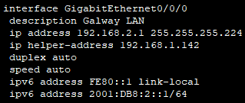
IP helper address to send DHCP message to the next hop, 192.168.1.142, in hopes the device at the next hop knows where the DHCP server is and forwards the message to it (IP routes also had to be implemented on the DHCP implemented MLS for the message to find its way back to the host)
Figure 2 – Excluded IP addresses in the DHCP LAN pool
DHCPv6 was chosen over SLAAC to assign IPv6 addresses to remote devices for security. DHCPv6 assigns IPv6 addresses to devices that send requests for them. SLAAC allows devices to automatically generate their own IPv6 address without needing the DHCPv6 server in the MLS to assign it. The last thing you’d want in an office is for a rogue device for a threat actor to be present and fully functional and unsuspicious within the network.
If there was another method that I knew that could implement this with full functionality, I would have done it the other way. This method is too costly in time to set up IPv6 and IPv4 addresses at every hop between the remote host and the MLS (with DHCP and DHCPv6 implemented).
Unfortunately, routing between IPv4 addresses in HQ and remote IPv6 networks isn’t fully functional. However, it shouldn’t be a problem for Emeral Retails HQ and the branch offices for the next few decades, since it’s for future scalability and can be implemented at a later stage.

    - Excluded IP Addresses

Excluded IP Addresses in relation to DHCP server configuration is used to take an IP address or a set of IP addresses out of a LAN pool to not assign these addresses dynamically. In my design, the reason I took out this set of IP addresses in figure 3 is that I wanted the SVIs on the Main MLS to have statically assigned IP addresses. We don’t want a statically assigned IP address to be dynamically assigned elsewhere at the same time. This can cause connection issues within the network.

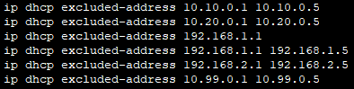
Figure 3 – Excluded IP addresses in different DHCP LAN pool

  - Layer 2 Security Measures
    - MAC Table Attacks

First things first, not even to mitigate MAC table attacks, but as common sense: shutdown unused ports. The thought of a rogue device easily accessing the network via plugging the device into a switch is laughable, but not to overlook. Not only that, but I moved unused ports to an unused and unconfigured VLAN. This is to ensure that even if a rogue device gains access to an unused port, they can’t access the network via this port.
Secondly, enabling port security on used access ports is a crucial step in enhancing network security by preventing unauthorized devices from connecting to the network. By configuring port security, the number of devices that are allowed to connect to each access port are limited, which MAC addresses that are permitted are specified, and issues like MAC address flooding attacks are prevented. This ensures that only authorized devices with known MAC addresses can access the network, mitigating the risk of rogue device access. Enabling port security also helps in tracking and monitoring devices, allowing network administrators to identify and respond to security breaches quickly. This proactive approach helps maintain a secure and stable network environment that reduces the potential for network disruptions or vulnerabilities.
Access ports below are set with certain policies and rules that trigger when an event occurs.
Switchport port-security – This enables port security on a port
Port-security maximum 5 – I set this at 5 for flexibility, since it’s an office setting and employees might like to connect their company-given devices to the network. This allows for some room for error without consequences and at the same time, secure.
Port-security violation restrict – If there are more than 5 MAC addresses are associated with a port, traffic from that port is simply discarded, violation counter is increased, and a log of the event is stored. I used this violation mode because Shutdown mode can be used against itself to cause a DDoS attack and Protect mode is simply doing too little in this office HQ setting.
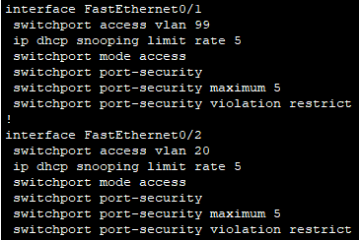
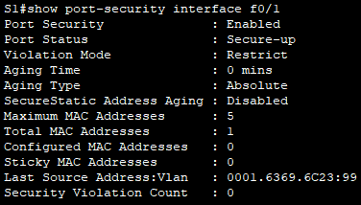
Figure 4 – Switchport verification in show run /// Figure 5 – Switchport config in show port-security
    - VLAN Attacks

To mitigate VLAN Hopping attacks, I implemented five things
- Manually enable trunking port
- Disable DTP negotiations on access and trunk ports and
- Disable unused ports – put them in disabled VLAN
- Set native VLAN away from VLAN 1
Before anything, I manually set trunking ports to trunk instead of the default of auto. An attacker can take advantage of auto by gaining access to the opposite end of the connection. Then, I disabled DTP negotiations using “switchport nonegotiate” on manually set access ports and trunk ports. This is so that an attacker can’t decide what mode a switchport can be by simply accessing the other end of the connection.
As mentioned before, disabled ports are also moved to an unused VLAN that has no configuration (See figure 1). This is another line of defence to mitigate a VLAN attack. If an attacker does manage to get access to a port, connect it and enable it, they would have to configure the disabled VLAN that the port is pre-configured to.
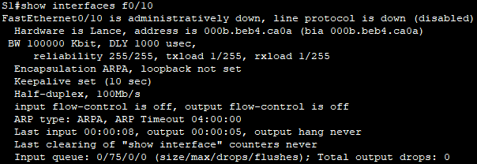
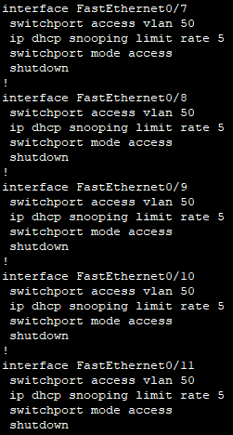
Finally, I created a Native VLAN of ID 99 (See figure 1). This is to carry user-generated traffic and allows us to move ports away from the default VLAN of 1. The users in the Native VLAN are the guests that need internet connection from HQ. User generated traffic needs to be separated from departments in the office for link load balancing and to act as just another line of defence against VLAN attacks.
Figure 7 – interface f0/10 “administratively down”
Figure 6 – Ports shutdown and set to Disabled VLAN

    - STP Attacks

To mitigate an STP attack, it is very simple. There are only basic two steps you can take that very simple and very effective.
- Enable PortFast
- Enable BPDU Guard
PortFast indirectly helps mitigate STP attacks by bringing a port immediately to the forwarding state and bypassing the listening and learning. This is helpful because the switch doesn’t learn from the false information coming in from a port that isn’t trusted or an intermediary device.
BPDU Guard immediately disabled a port that receives a BPDU message. This should only be configured on interfaces that are attached to end devices, as with PortFast. Both I set by default because as the company grows, there will be more users and more devices, meaning more time to go to each interface and set up every new device. Instead, I set it in the global config mode to apply it to all access ports.
Figure 8 – “show run” shows both are set in global config mode on default settings

    - DCHP Attacks

To mitigate DHCP attacks (DHCP spoofing and DHCP starvation), it is also very simple and very effective. In three basic steps, I implemented basic mitigation against the two common DHCP attacks.
- Enable DHCP snooping in global config and by VLAN
- On trusted ports, use “ip dhcp snooping trust”
- On untrusted ports, limit number of DHCP discovery messages received
Below, f0/3 is a trusted port receives incoming messages from the DHCP server, and f0/4 is an untrusted port that receives incoming messages from an end device.
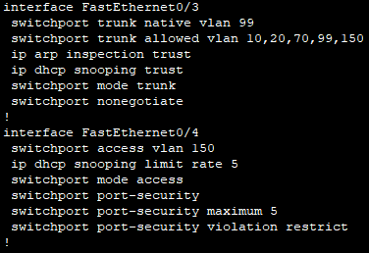
Figure 9 - On f0/3, ip dhcp snooping trust is set.
On f0/4, there’s an ip dhcp snooping limit rate of 5, this limits the number of DHCP messages allowed through this port from different MAC addresses
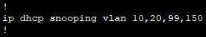
Figure 10 – ip dhcp snooping enabled on set VLANS

    - ARP Spoofing

To mitigate ARP spoofing attacks, all I had to do was add on two more steps from mitigating DHCP attacks (It is important that DHCP snooping is enabled).
- Enable Dynamic ARP Inspection (DAI) on selected VLANS
- Configure trusted interfaces for DHCP snooping and ARP inspection
DAI verifies each intercepted packer for a valid IP-to-MAC binding. If it finds it invalid, the packet is dropped, the event is logged, and no ARP spoofing attack to worry about.
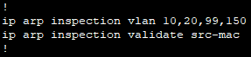
Figure 11 – ARP inspection enabled on set VLANS. ARP inspection is set to validate source mac address in header against sender MAC address in ARP body.

  - SSH to Headquarters’ Edge Router

For my implementation, SSH was chosen to remotely access this router by two network administrators in figure 12 below. This is a much safer and more secure option than telnet because it requires a username and a password that are stored in a local database in the router. A 2048-bit RSA key was generated to encrypt communication between the host accessing and the router. You can imagine it slows the router down a bit because it is a longer key. Longer key = more secure, but more secure = longer time to decrypt.
The two network admins are:
- Username: admin1 – Password: cisco
- Username: admin2 – Password: cisco
These credentials should NOT be set as SSH local login, they’re only set here as an example.

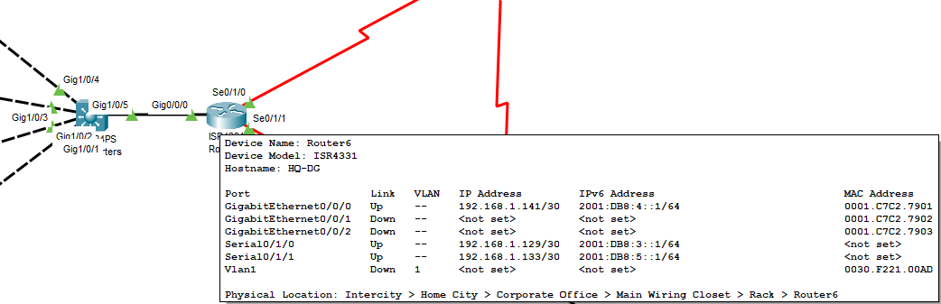
Figure 12 – note the IPv4 address on interface g0/0/0
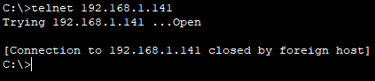
Try telnet into the router and it will not work and give the following error message.
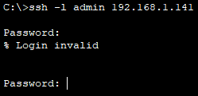
Try SSH login with a username that doesn’t exist in the local database, and it will give the following error message.
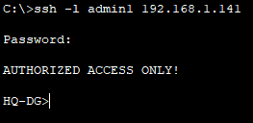
Give correct credentials and I get access to the router OS.

  - Static Routes for External Communication

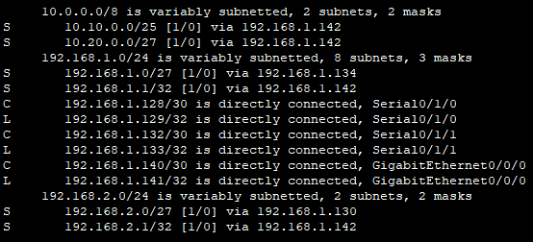
As part of my implementation of static routes in the topology, I decided it is best that there be no static default routes between the three routers. This is because none of them are stub routers. Instead, I implemented basic ip static routes and as a backup, added floating static routes. This was set in case one link goes down, connectivity and communication between the offices is still up and running. The IP addresses I used between the links are set to a /30 subnet because there are only the two interfaces between both devices so only two IP addresses are needed in the network. This ensures efficient IP address usage with very little waste compared to a /24 subnet.
Figure 13 – Routing table of HQ router

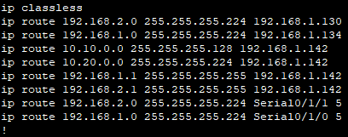
Figure 14 – HQ router - Floating static routes end in “5” – administrative distance higher than normal static routes. To ensure floating static routes are treated as backup and not main route.
Since the branch offices in Cork and Galway have IPv6 fully implemented and functional, it’s only right to ensure external connectivity between those.
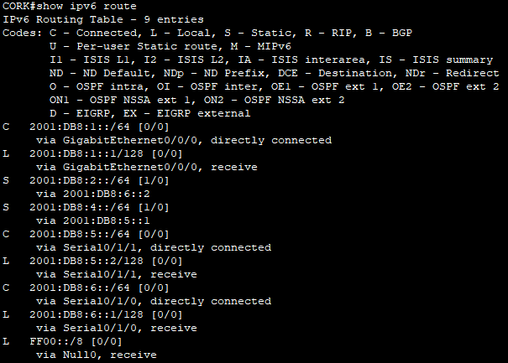
Figure 15 – IPv6 routing table of CORK router – shows IPv6 networks directly connected and statically assigned routes

For this, I set no backup floating routes, as IPv6 is still experimental between these networks and not fully functional yet. Instead, only a temporary static route is assigned through one route between the routers.

  - Branch offices IP Address allocation

Each branch office in Cork and Galway obtain their IPv4 and IPv6 addresses through the MLS at HQ which is configured to act as DHCP and DHCPv6 servers for both branches (and IPv4 only for HQ). This was chosen instead of standalone servers to ease the load of maintenance on the management team in the office.
At least 30 usable IP addresses are available for assignment at the Cork and Galway offices with their own network address and range that are dynamically assigned by the MLS at HQ.
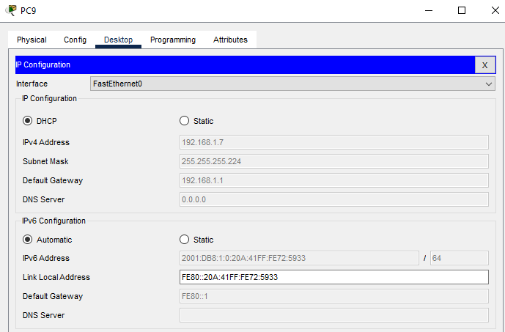
Figure 16 – DHCP functional and Automatic IPv6 allocation functional from Galway PC

  - Basic Wireless Network

A few issues to address before I explain my implementation.
- WPA3 encryption couldn’t be accessed
- SSID broadcasting couldn’t be disabled
- MAC filtering couldn’t be enabled
These all couldn’t be configured simply because I couldn’t access the WLC from a PC within my network or its network. Instead, I had improvised and chose a WLC model that didn’t require another device to access its OS and that had built in options to get a basic WLAN working.

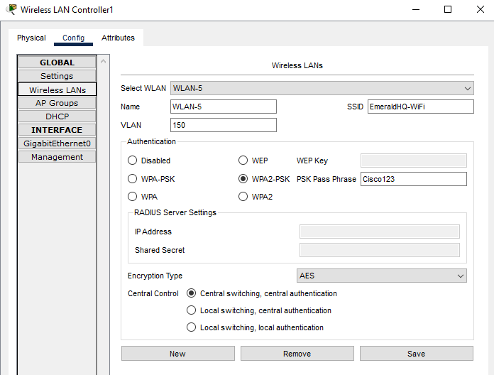
Figure 17 – WLC WLAN Configuration
As improvision, I set the encryption method to WPA2-PSK. This is the latest one in this WLC model that uses a passkey. This is to ensure the most secure environment possible with the equipment available. Even though MAC filtering is disabled and SSID broadcasting is enabled, there is still a passkey for attackers to get through to access this network.
I also saw that there was a DHCP option and thought, why not? So, I set it up on the WLC for devices on VLAN 150 to get an IP address on network 192.168.50.0/24. This made it easier for me to troubleshoot problems later without having to manually set IP addresses on each wireless device.

- Conclusion

In conclusion, I believe my design for Emerald Retail Ltd is best because it meets (almost) all 7 requirements of:
- Departmental Segmentation using VLANs
- Dynamically allocated IPv4 and IPv6 addresses with subnetted networks
- Layer 2 Security Measures
- SSH to Headquarters’ Edge Router
- Static Routes for External Communication
- Branch offices IP Address allocation
- Basic Wireless Network
Not only does my design meet all requirements, but it is future proof.
The network got segmented into different VLANs depending on departments. On top of the recommended VLANs to add, I added more to ensure traffic around the network is properly separated. Each VLAN has its own description for future configurations in the HQ. This reduces workload for the network management team.
Additionally, it fully supports, with full functionality, DHCP (For devices in HQ AND branching offices) and DHCPv6 (For devices in branching offices). Not only can devices communicate within each network, but they can communicate with other devices on other networks. This is crucial for HQ to be able to send and receive data saved on external devices in branching offices.
Layer 2 Security measures have been taken to reduce the chances of an attacker attacking the layer 2 devices in HQ’s network infrastructure. Mitigated attacks include:
- MAC Table Attacks
- VLAN Attacks
- STP Attacks
- DHCP Attacks
- ARP Spoofing
This is to ensure layer 2 devices are protected from attacks and secure for users within the network.
Only SSH has been configured to remotely connect to the HQ router by only two administrators with their credentials stored and encrypted in a local database in the router. This is in case a network administrator wants to check or change configuration in the router. A 2048-bit RSA encryption key is used to encrypt communication between device connecting and HQ router. This ensures maximum security when accessing and configuring the router.
For IPv4, not only have static routes been fully configured for efficiency and redundancy between the three routers, but floating static routes have also been implemented as a backup. However, since IPv6 is expected to be fully implemented and functional in the future, I decided to set up basic IPv6 routes on the branching offices’ routers as an experiment. Even though this is still not fully functional yet, messages can be sent and received via IPv6 between the branching offices, but not yet to and from HQ.
Each branching office has its own IP address allocation with at least 30 usable IP addresses which are dynamically assigned by the MLS at HQ. Not only that, but IPv6 addresses are also dynamically assigned by the MLS at HQ to the branch offices in Cork and Galway. This is a way of future proofing and preparing for scalability.
Finally, the HQ office includes a basic wireless network configuration that supports mobile devices. The WLC assigns addresses via built-in DHCP to devices connected wirelessly. This ensures wireless clients are separated from clients on other devices. To take this a step further, a separate has been created for wireless devices. Inter-VLAN routing and communication works perfectly between wireless devices and other devices in HQ.

